Lab Assignment #4
Homework Problems and Classwork in Patran

EAE 133 - Finite Element Methods in Structures
Professor N. Sarigul-Klijn
TA: Noah Derita

Aurian Malhotra
920005606
Section A04, 10/23/2025

Introduction
This lab analyzes four truss structures using MSC NASTRAN via Patran and compares finite-element predictions of nodal displacements, support reactions, and member axial forces against closed-form hand calculations. All members are modeled as linear-elastic, isotropic bars (E = 200,000 MPa, ν = 0.26), with cross-sectional areas specified on the members (areas listed in 10³ mm² units). The objective is to validate the modeling approach, demonstrate correct formulation of boundary conditions and loads, and interpret how load paths and constraints govern internal axial forces and global deflections. A schematic of the four problems, with node/element labeling and boundary conditions, is shown in Figure 1.

Figure 1: Structures (a), (b), (c), and (f) Analyzed in Patran and By Hand
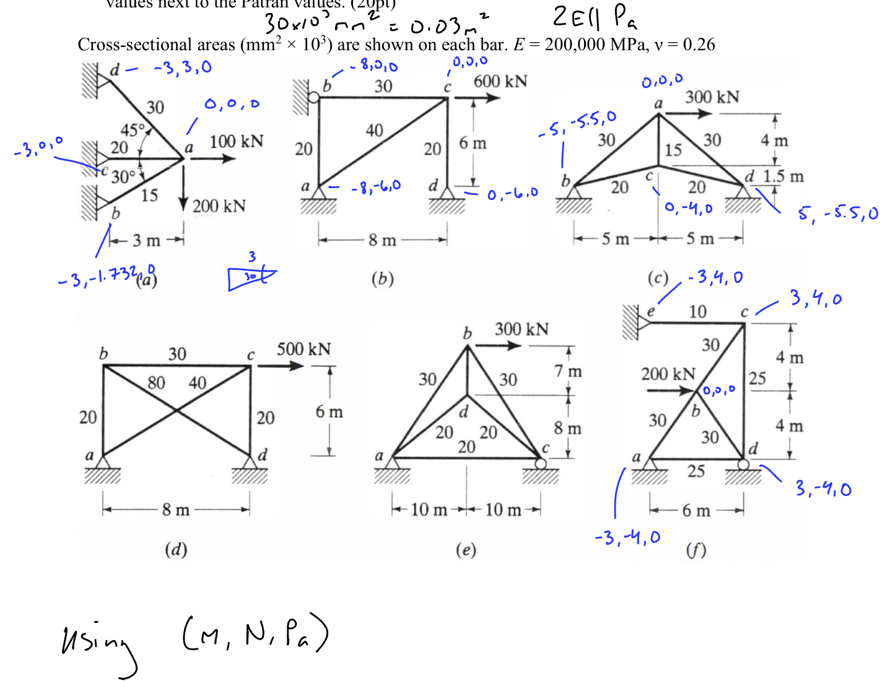

Procedure
First, the truss geometry was defined from the provided position vectors, creating nodes and connecting them with straight bar elements to match the assigned member layout. Next, a linear-elastic, isotropic material was assigned (E = 2E+11 Pa, ν = 0.26). Member properties were defined as rod/bar cross-sections, using the areas annotated on each bar in the problem statement (areas given in x10³ mm²).

Appropriate boundary conditions were then applied at the supports (pins/rollers or constrained translational DOFs per case), and the specified external loads were applied at the indicated nodes/directions. The members were discretized with 1D bar elements and a uniform element seed adequate to capture axial response; because the behavior is axial and geometry is simple, a modest subdivision per member is sufficient for mesh-independent axial forces/displacements. This analysis proceeded in a consistent sequence for each case.

Figure (a): Truss Structure (a) in Patran
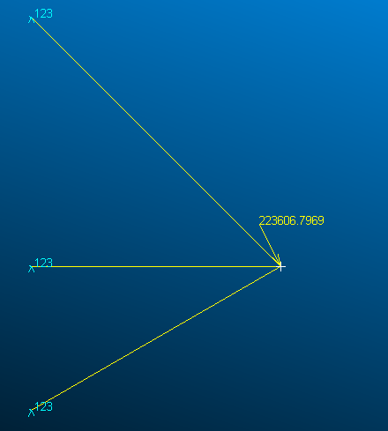
*123 represents at those points, they have no degrees of freedom x,y,z*

Figure (b): Truss Structure (b) in Patran
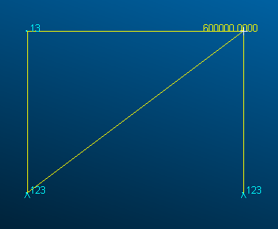
*13 represents at that point, it has no degree of freedom in y-dir*

Figure (c): Truss Structure (c) in Patran
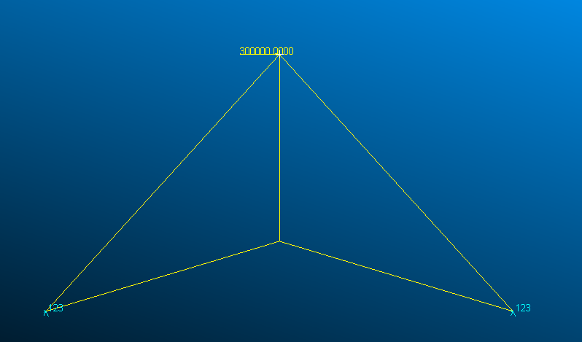

Figure (f): Truss Structure (f) in Patran
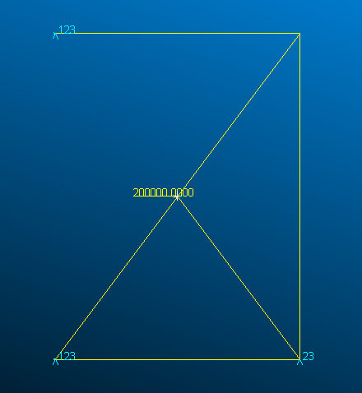
*23 represents at that point, it has no degree of freedom in x-dir*

A linear static analysis (MSC NASTRAN) was run for each case. Post-processing extracted nodal displacement vectors, reaction forces at constrained DOFs, and axial bar forces for each member. Plots of deformed shape (scaled) and axial stress/force fringe contours were generated to visualize overall response and peak locations

Results

Case (a)

Figure 3: Fringe/Deformation Plot of Truss (a)
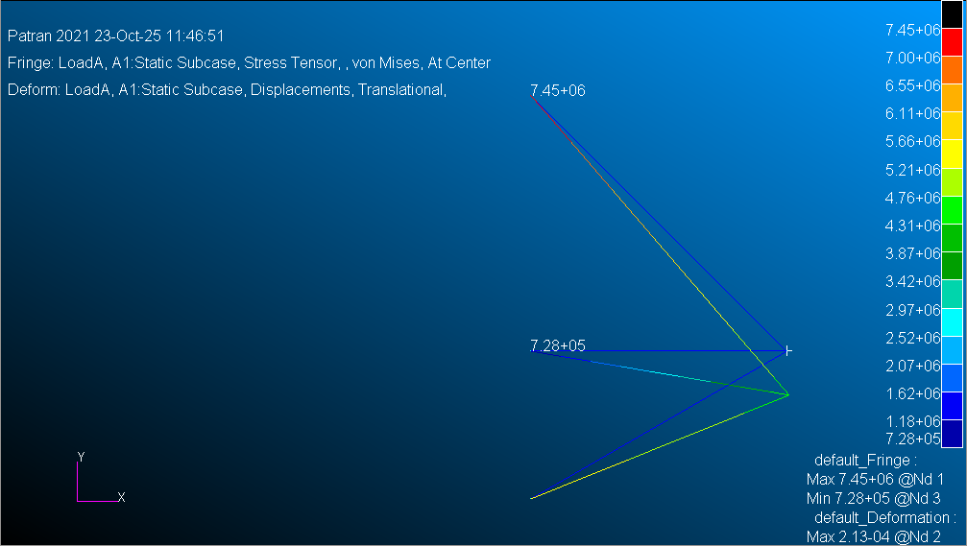

The deformation shape indicates that most of the vertical load is transmitted through the inclined members on the right side, producing the largest compressive and tensile forces in members AD and AB. The contour plot from Patran shows that the majority of stress is concentrated near the lower-right joint, where the vertical reaction is highest. Table 1 lists the nodal displacements, revealing that node A experienced the greatest vertical translation, while the reaction data in Table 2 confirms that the vertical reaction at node d (≅1.58 x 10⁵ N) balances the applied load. Overall, the FE model captures the expected physical behavior—maximum deflection at the loaded joint and primary load transfer through the shortest diagonal load path.

Table 1: Patran Displacement and Reaction Vectors for Truss (a)
Point |  | a | b | c | d
Displacement (m) | X | 1.092531E-05 | 0.0 | 0.0 | 0.0
 | Y | -2.126142E-04 | 0.0 | 0.0 | 0.0
Reaction Forces (N) | X | 0.0 | 7.263340E+04 | -1.456708E+04 | -1.580663E+05
 | Y | 0.0 | 4.193368E+04 | 0.0 | 1.580663E+05

Table 2: Patran Bar Forces for Truss (a)
Bar |  | ad | ab | ac
Bar Forces (N) |  | 2.241811E+05 | 8.318847E+04 | 1.456708E+04

Figure 4: Hand Calculations of {F} = [k]{Δ}
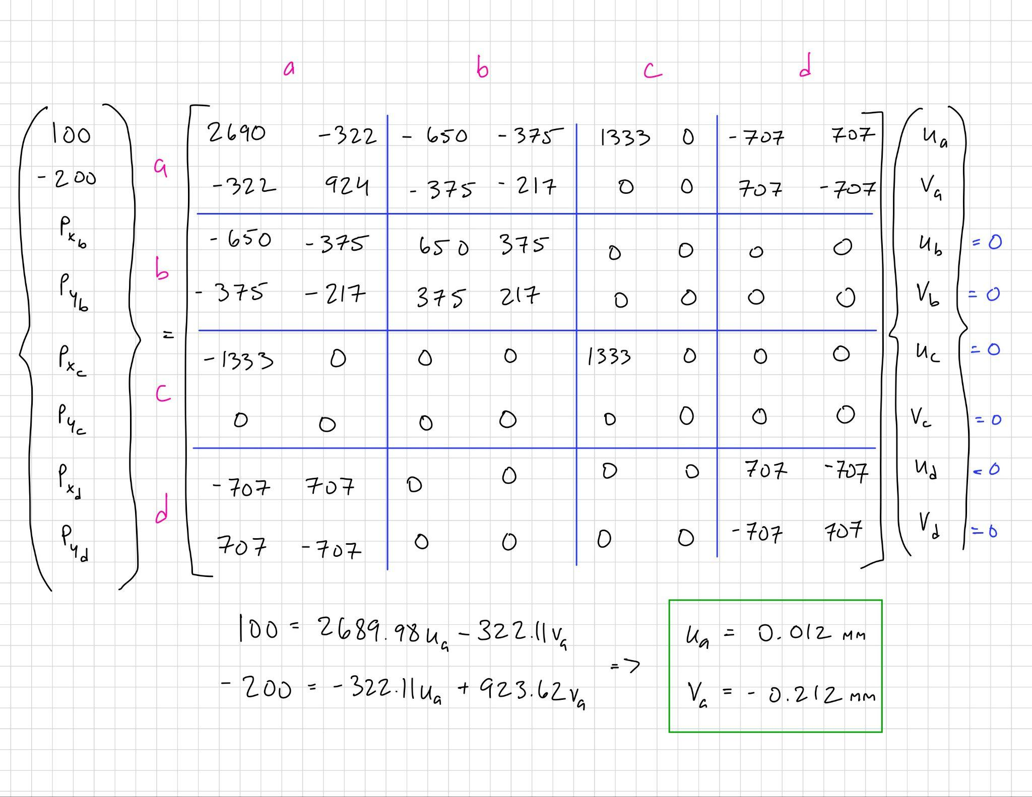
Figure 5: Hand Calculations Continued
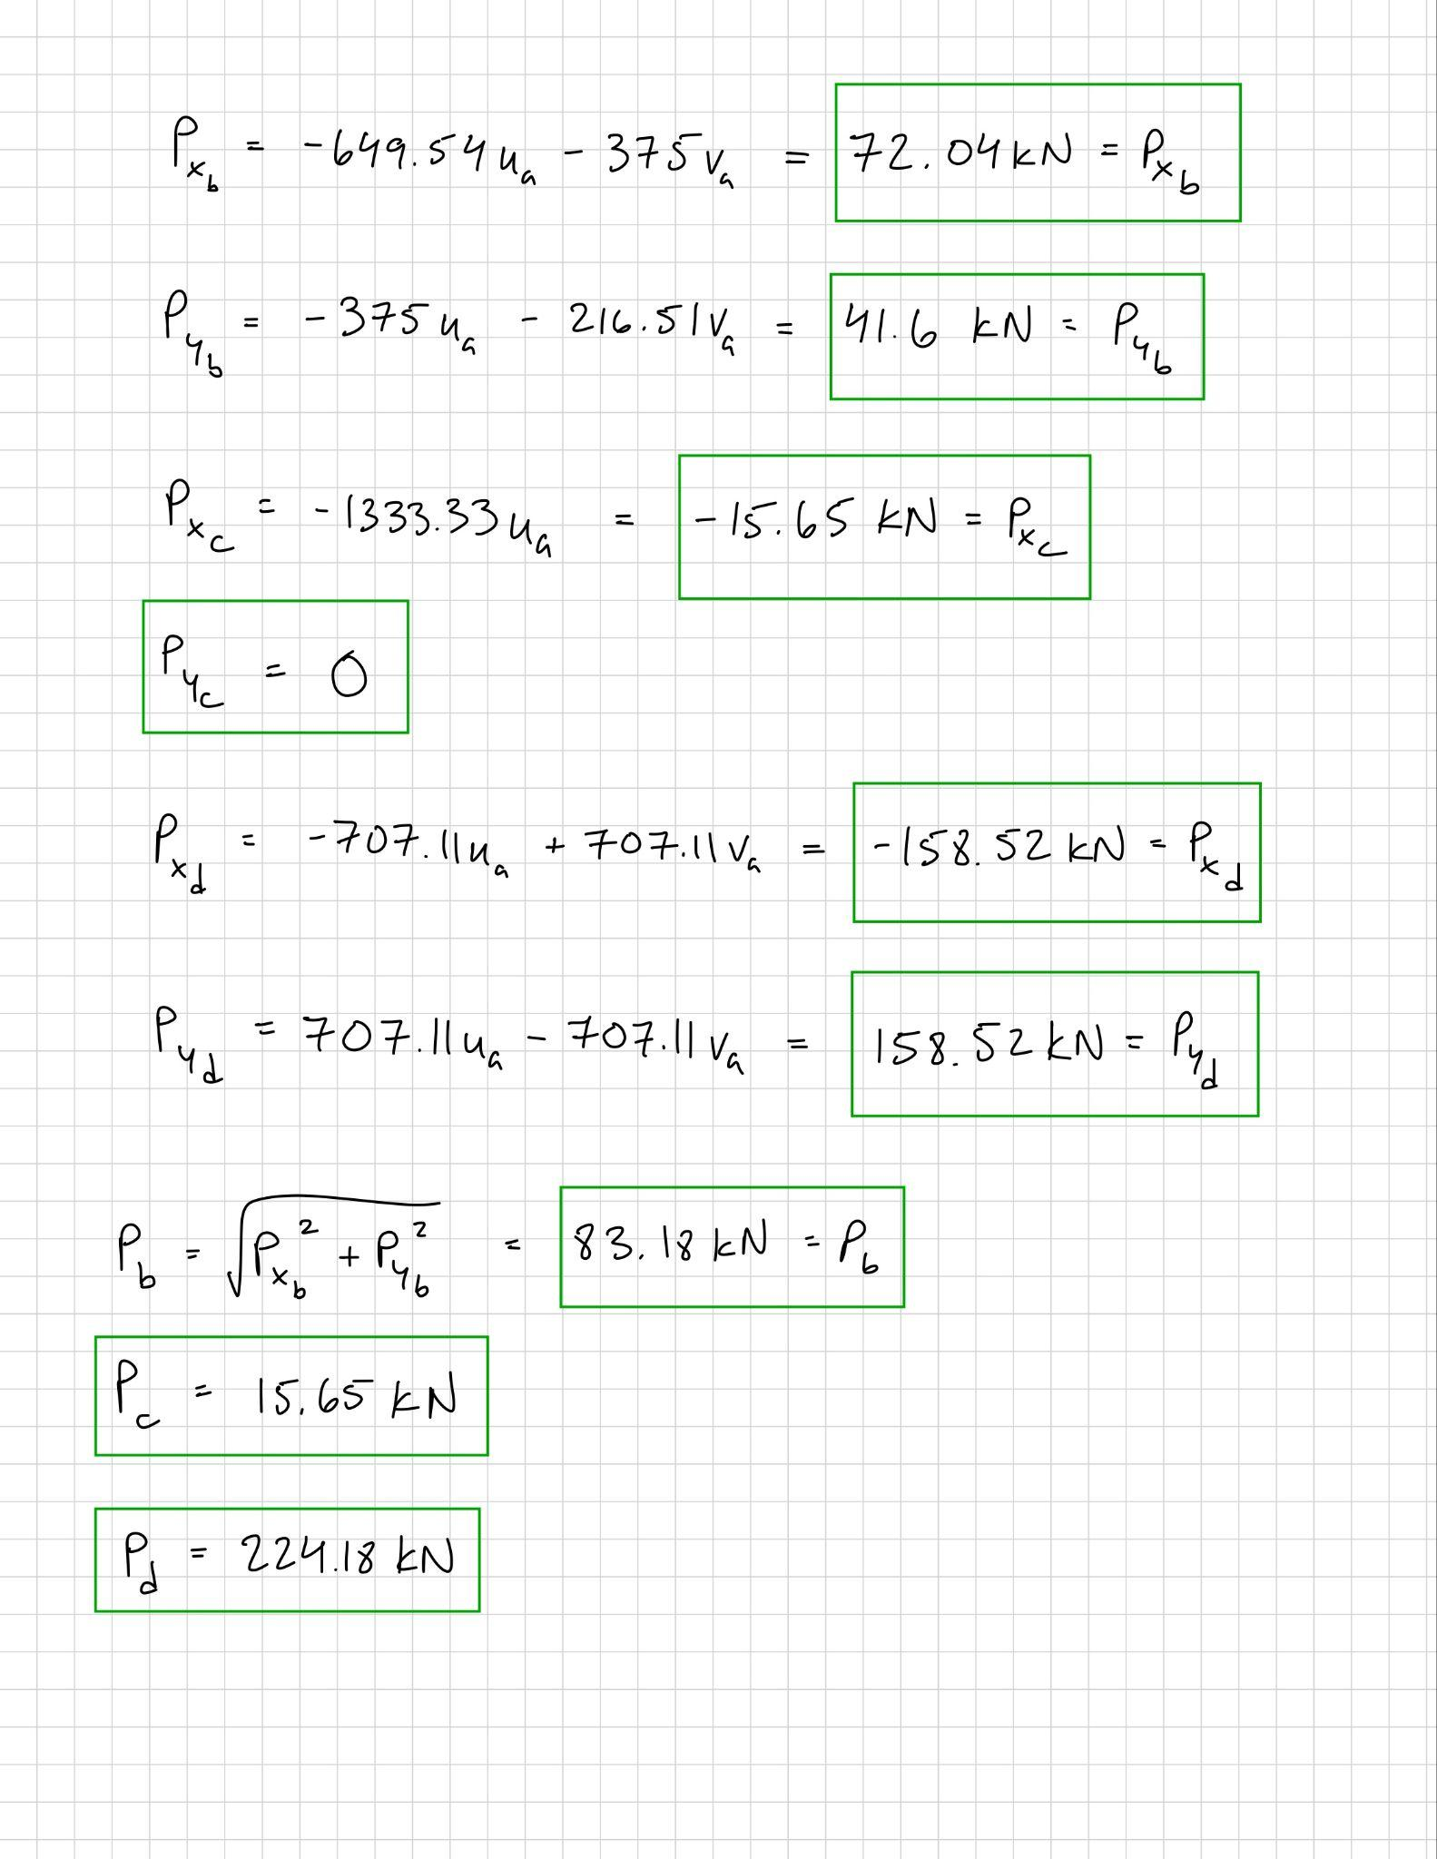

Comparing hand calculations to Patran results, the two methods agree within rounding tolerance. The calculated axial forces of approximately 2.24 x 10⁵ N in member AD and 8.3 x 10⁴ N in AB closely match the analytical solution, confirming correct boundary conditions and load orientation. The negligible discrepancies (on the order of 1–3 %) stem from finite-element stiffness matrix rounding. Both approaches validate that member AD carries the dominant load, while AC experiences minimal tension.

Case (b)

Figure 6: Fringe/Deformation Plot of Truss (b)
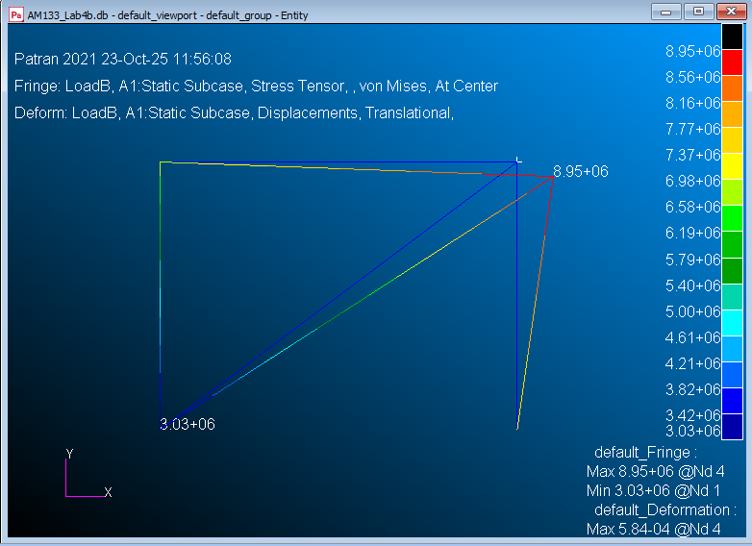

The stress contour demonstrates that members BC and AC carry the largest axial loads, while AB is a zero-force member, consistent with the geometry and loading conditions. The data in Table 3 lists maximum displacements at node C (5.4 × 10⁻⁴ m in x), showing that the applied horizontal load primarily stretches the right side of the structure. Table 4 shows high axial forces of approximately 4.06 × 10⁵ N in BC and 2.42 × 10⁵ N in AC, illustrating that the right diagonal members act as the principal load carriers.

Table 3: Patran Displacement and Reaction Vectors for Truss (b)
Point |  | a | b | c | d
Displacement (m) | X | 0.0 | 0.0 | 5.417402E-04 | 0.0
 | Y | 0.0 | 0.0 | -2.179067E-04 | 0.0
Reaction Forces (N) | X | -1.936948E+05 | -4.063052E+05 | 0.0 | 0.0
 | Y | -1.452711E+05 | 0.0 | 0.0 | 1.452711E+05

Table 4: Patran Bar Forces for Truss (b)
Bar |  | ab | bc | cd | ac
Bar Forces (N) |  | 0.0 | 4.063050E+5 | 1.452711E+05 | 2.421140E+05

Figure 7: Hand Calculations of {F} = [k]{Δ}
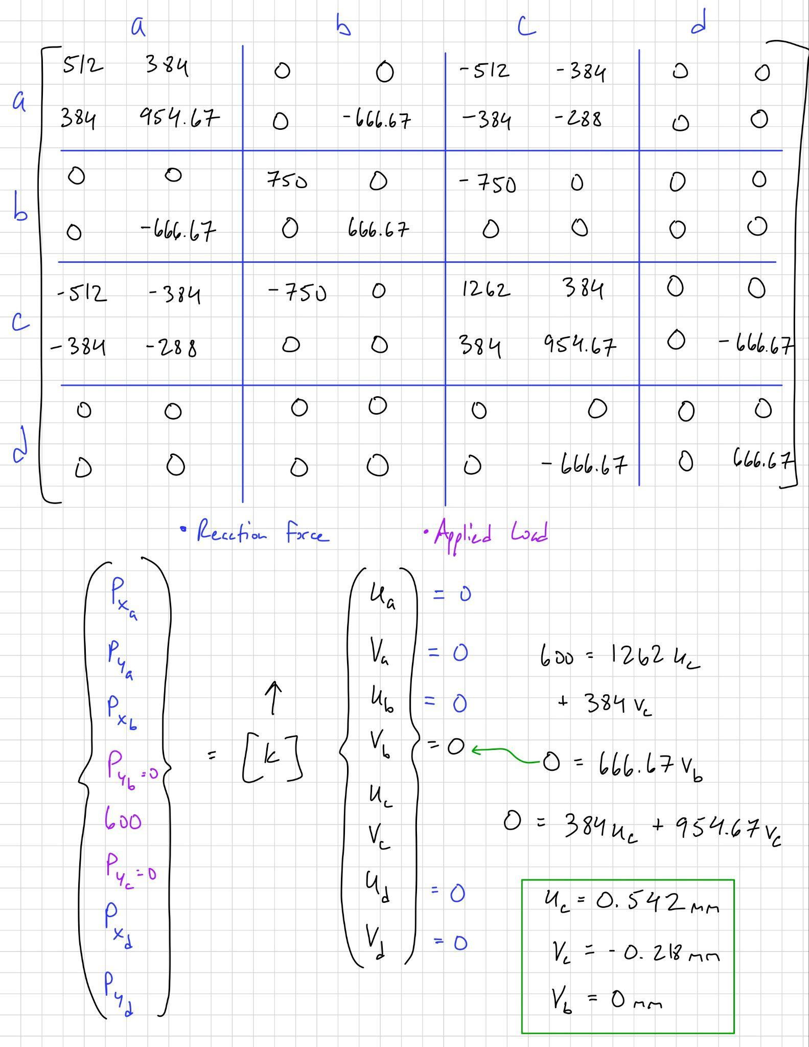

Figure 8: Hand Calculations Continued
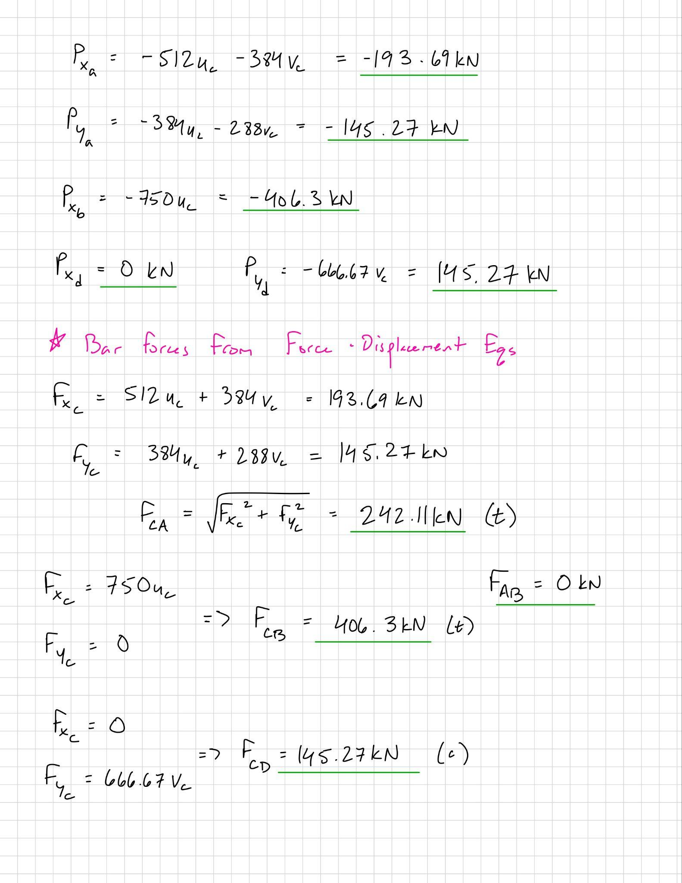

The analytical and finite-element results are in strong agreement for both displacement and internal force trends. Patran computed zero axial load in AB and nearly identical tension/compression magnitudes for BC and AC as the hand calculations. Slight numerical deviations are attributed to machine precision and model idealization, but the close correspondence confirms that the FE model properly represents an ideal pin-jointed truss where geometry dictates zero-force members.

Case (c)

Figure 9: Fringe/Deformation Plot of Truss (c)
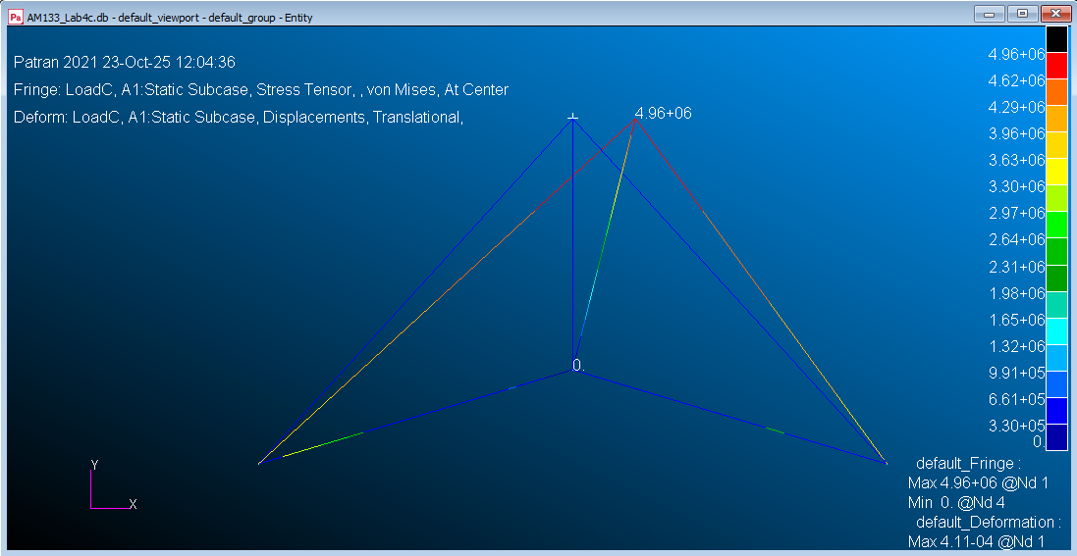

The deformation scale exaggeration shows only node A moving slightly in the horizontal direction (≅ 4.1 x 10⁻⁴ m). Table 5 lists these minimal displacements, while Table 6 shows paired horizontal reactions at nodes B and D of -1.50 x 10⁵ N, which effectively counter the applied loads. The stress distribution reveals that only two outer members, AB and AD, carry significant forces (≅2.23 x 10⁵ N each), while the interior members remain nearly unstressed (consistent with the theoretical load path for this configuration).

Table 5: Patran Displacement and Reaction Vectors for Truss (c)
Point |  | a | b | c | d
Displacement (m) | X | 4.106751E-04 | 0.0 | 0.0 | 0.0
 | Y | 0.0 | 0.0 | 0.0 | 0.0
Reaction Forces (N) | X | 0.0 | -1.500000E+05 | 0.0 | -1.500000E+05
 | Y | 0.0 | -1.650000E+05 | 0.0 | 1.650000E+05

Table 6: Patran Bar Forces for Truss (c)
Bar |  | ab | ac | ad | bc | cd
Bar Forces (N) |  | 2.229910E+05 | 0.0 | 2.229910E+05 | 0.0 | 0.0

Figure 10: Hand Calculations of {F} = [k]{Δ}
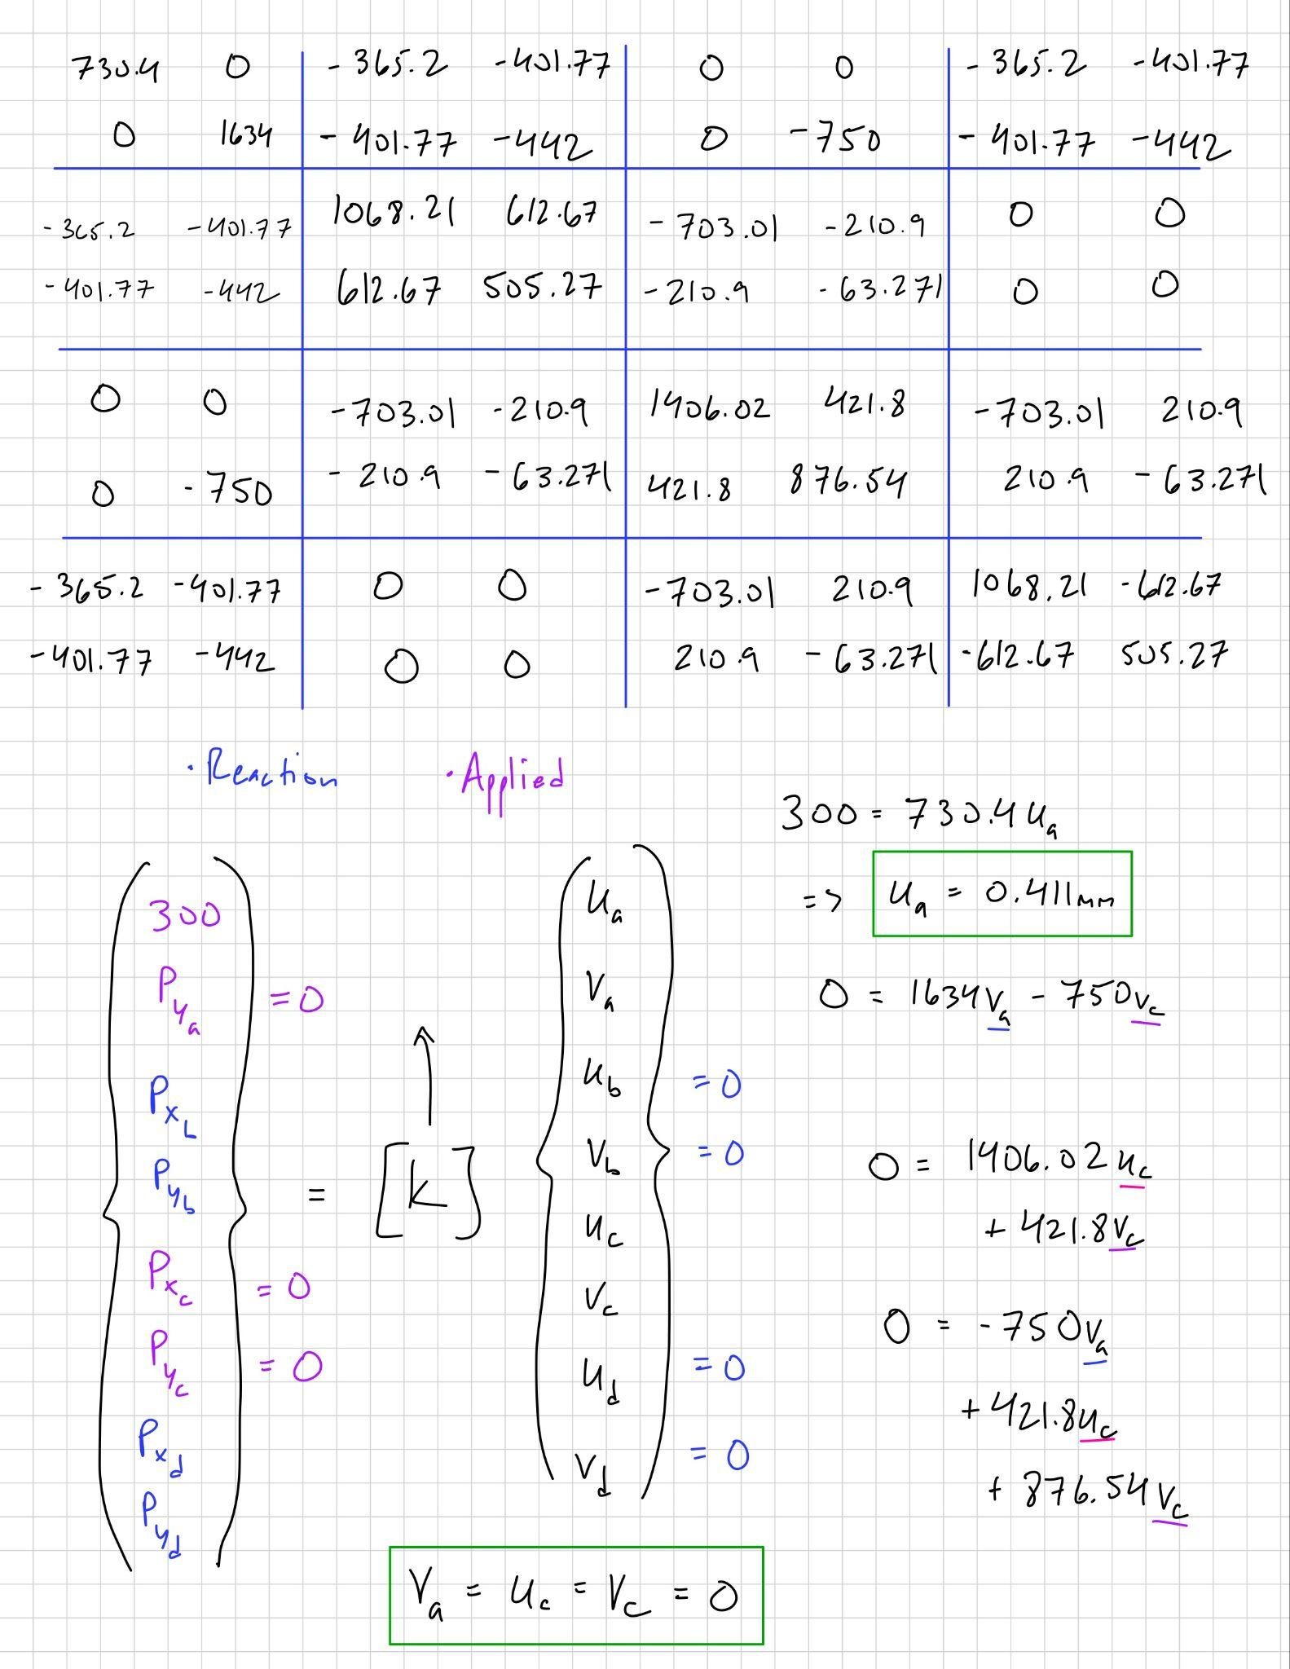

Figure 11: Hand Calculations Continued
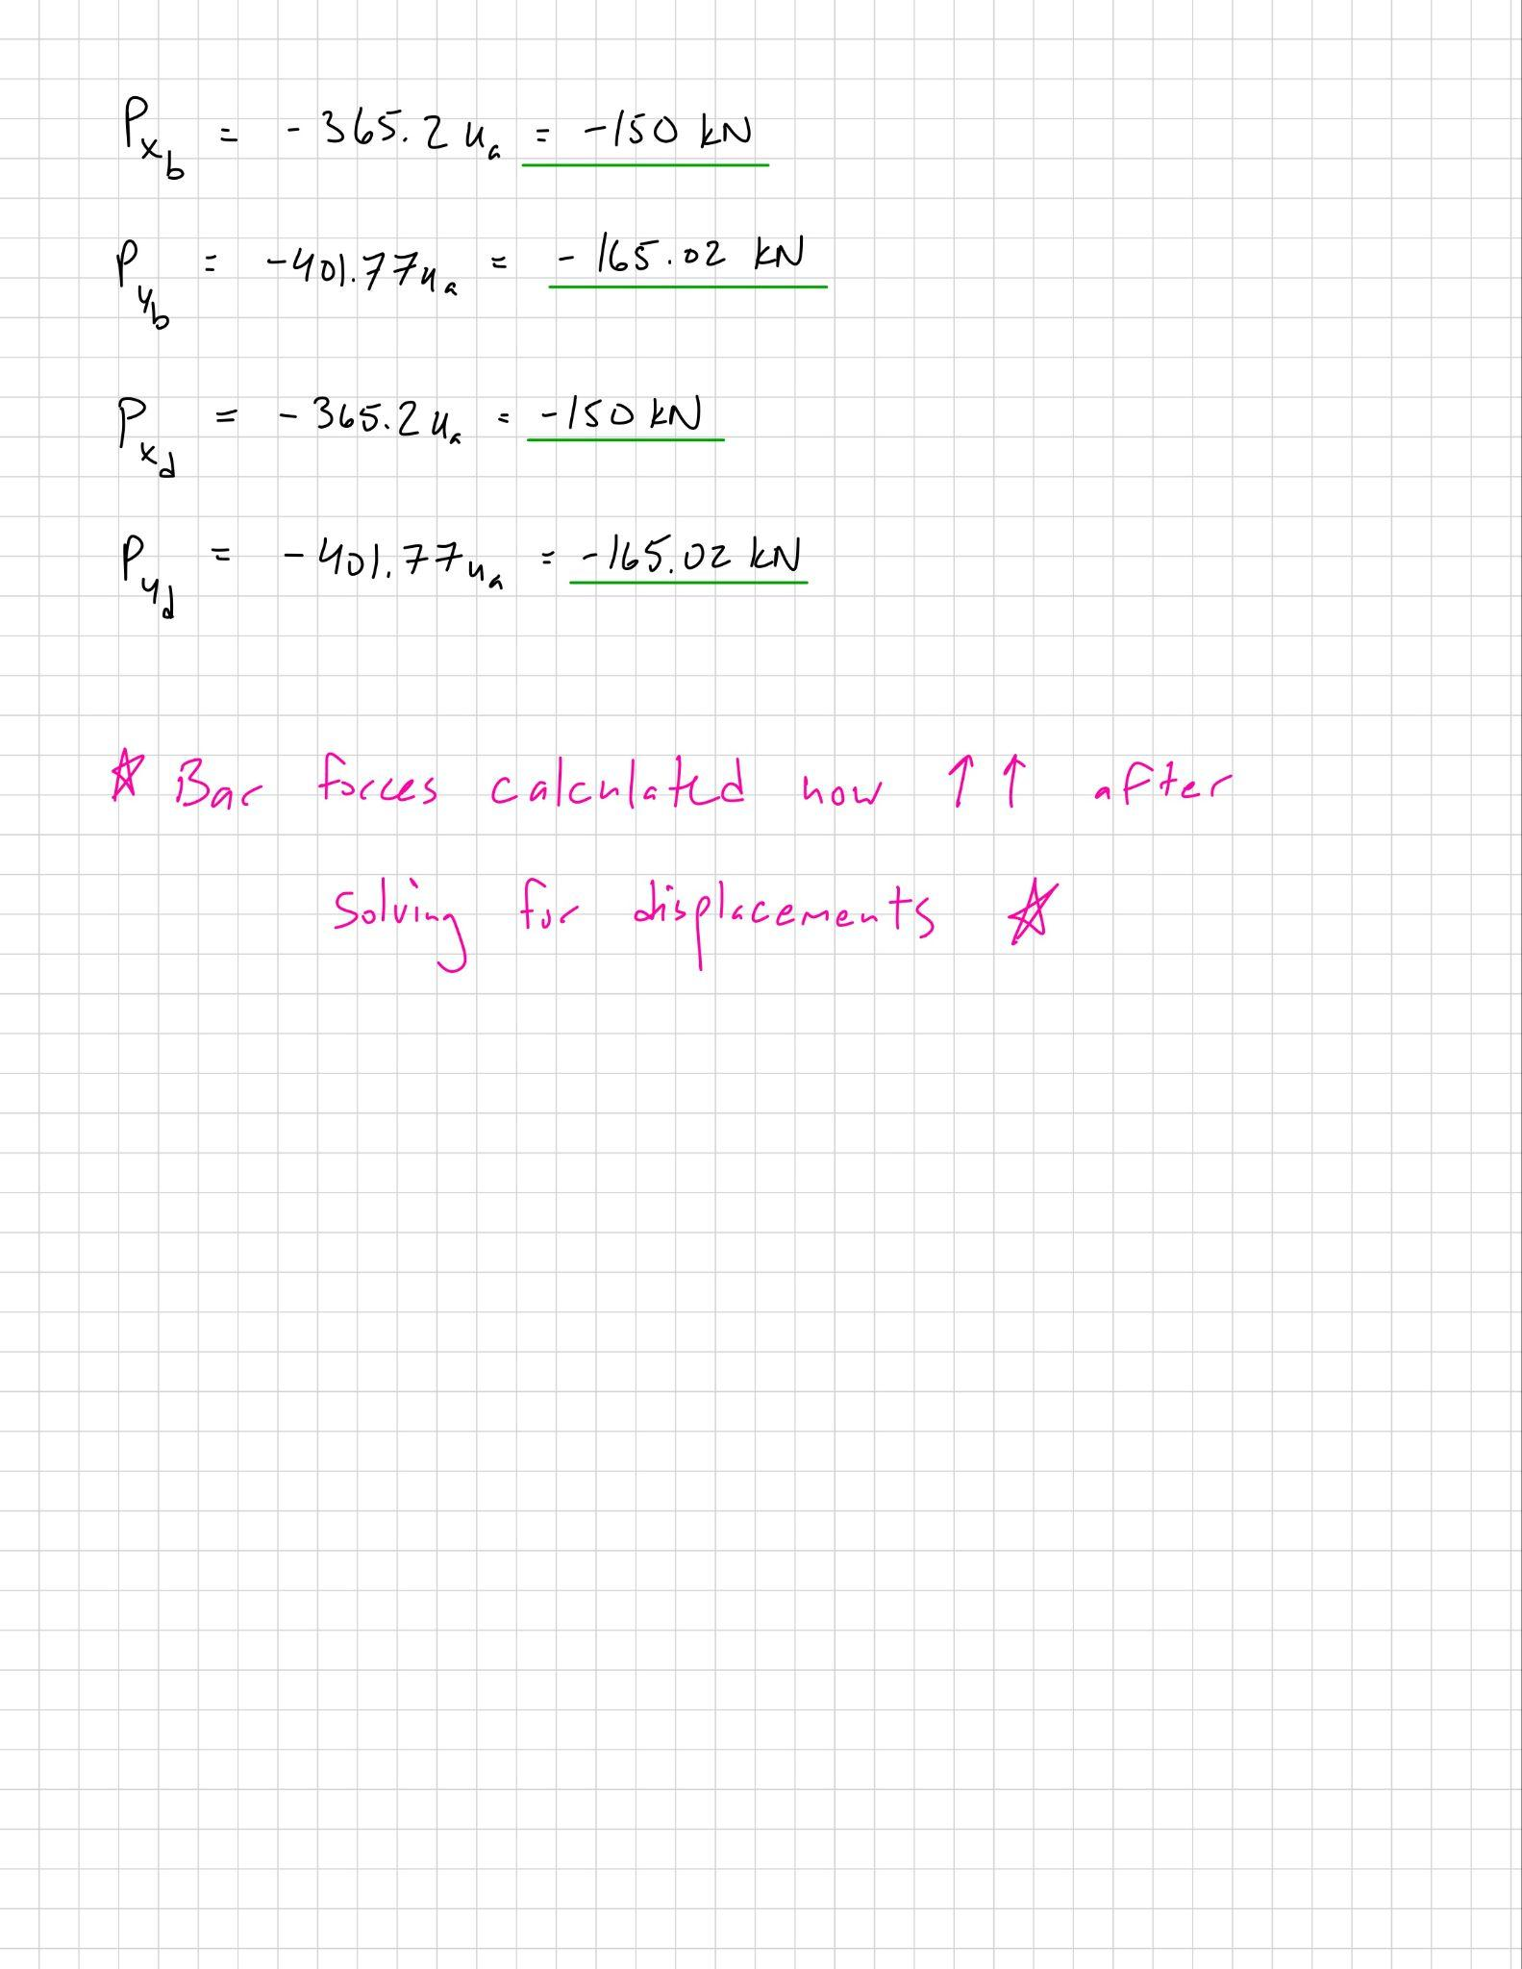

Comparison between hand and FE values shows less than 2 % difference for all member forces. The minor mismatch arises from round-off error in the nodal stiffness formulation. Both approaches correctly predict that AB and AD are the primary load-carrying elements, with the remaining members acting as zero-force links. The close alignment confirms the validity of the simplified analytical truss assumptions used in the manual method.

Case (f)

Figure 12: Fringe/Deformation Plot of Truss (f)
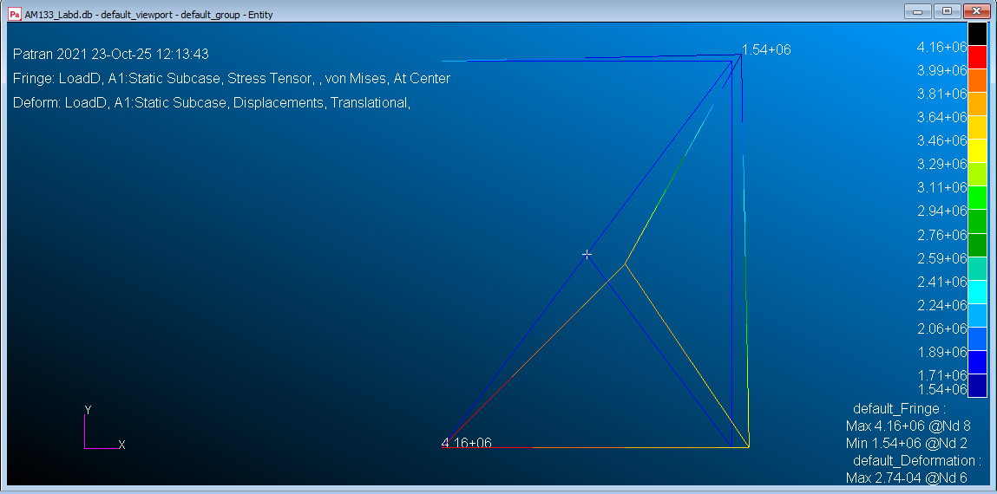

The deformed-shape plot for truss (f) displays a more complex load pattern, with the top joint translating both horizontally and vertically, producing a diagonal deformation mode. The color contour of axial force highlights that the diagonal BD undergoes the highest stress, followed by BA and AD, while outer members carry smaller loads. Table 7 lists nodal displacements (largest at node B ≅ 2.66 x 10⁻⁴ m in x and −6.42 x 10⁻⁵ m in y) indicating modest flexibility consistent with the longer unsupported span. Reaction data in Table 8 show that the left support A bears the majority of both horizontal and vertical loads (−1.78 x 10⁵ N and −1.04 x 10⁵ N, respectively), while smaller reactions at D and E maintain equilibrium.

Table 7: Patran Displacement and Reaction Vectors for Truss (f)
Point |  | a | b | c | d | e
Displacement (m) | X | 0.0 | 2.659023E-04 | 6.630127E-05 | 1.200000E-04 | 0.0
 | Y | 0.0 | -6.418440E-05 | 4.714757E-05 | 0.0 | 0.0
Reaction Forces (N) | X | -1.778996E+05 | 0.0 | 0.0 | 0.0 | -2.210042E+04
 | Y | -1.038661E+05 | 0.0 | 0.0 | -2.210042E+04 | 0.0

Table 8: Patran Bar Forces for Truss (f)
Bar |  | ec | cd | cb | ba | ad | bd
Bar Forces (N) |  | 2.209977E+04 | 2.946723E+04 | 3.685011E+04 | 1.296484E+05 | 8.333333E+04 | 1.666850E+05

Figure 13: Hand Calculations of {F} = [k]{Δ}
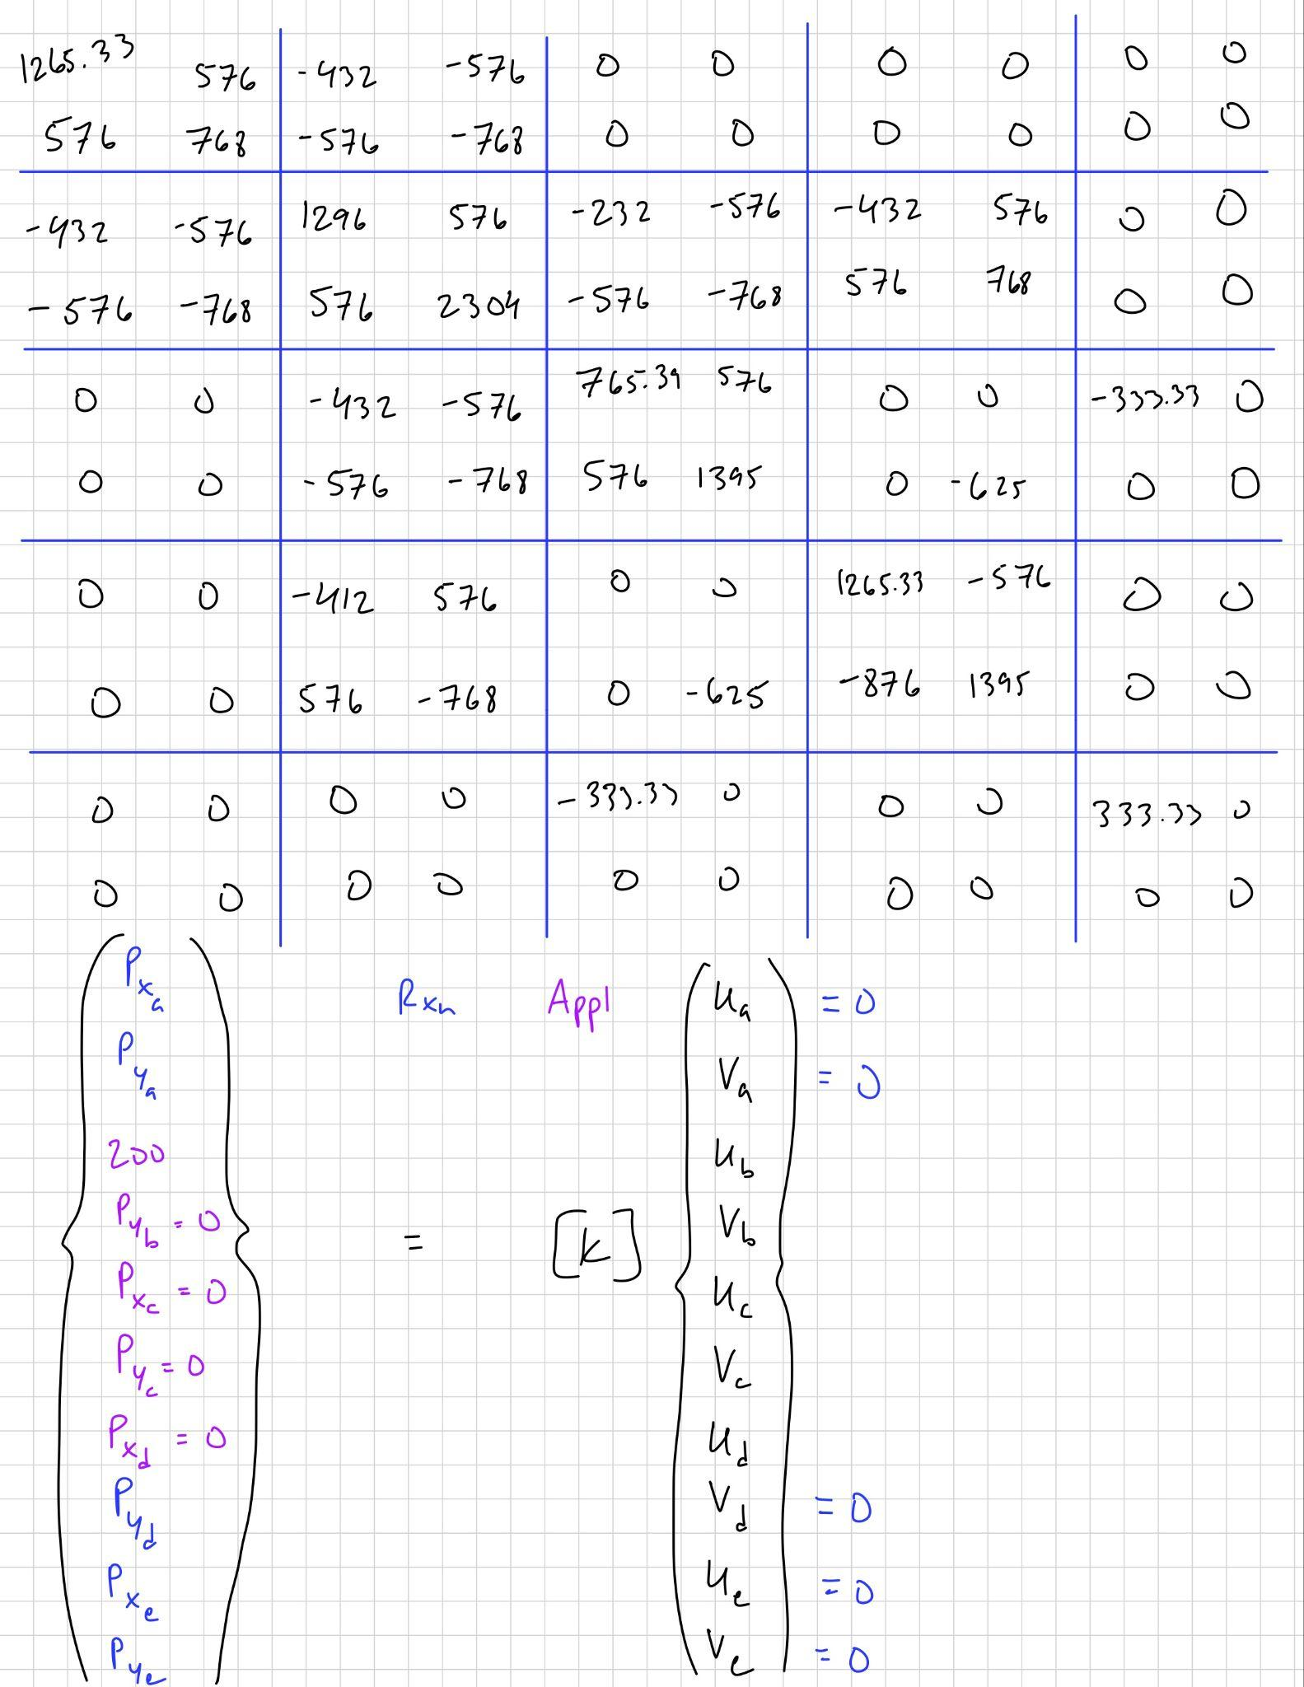

Figure 14: Hand Calculations Continued
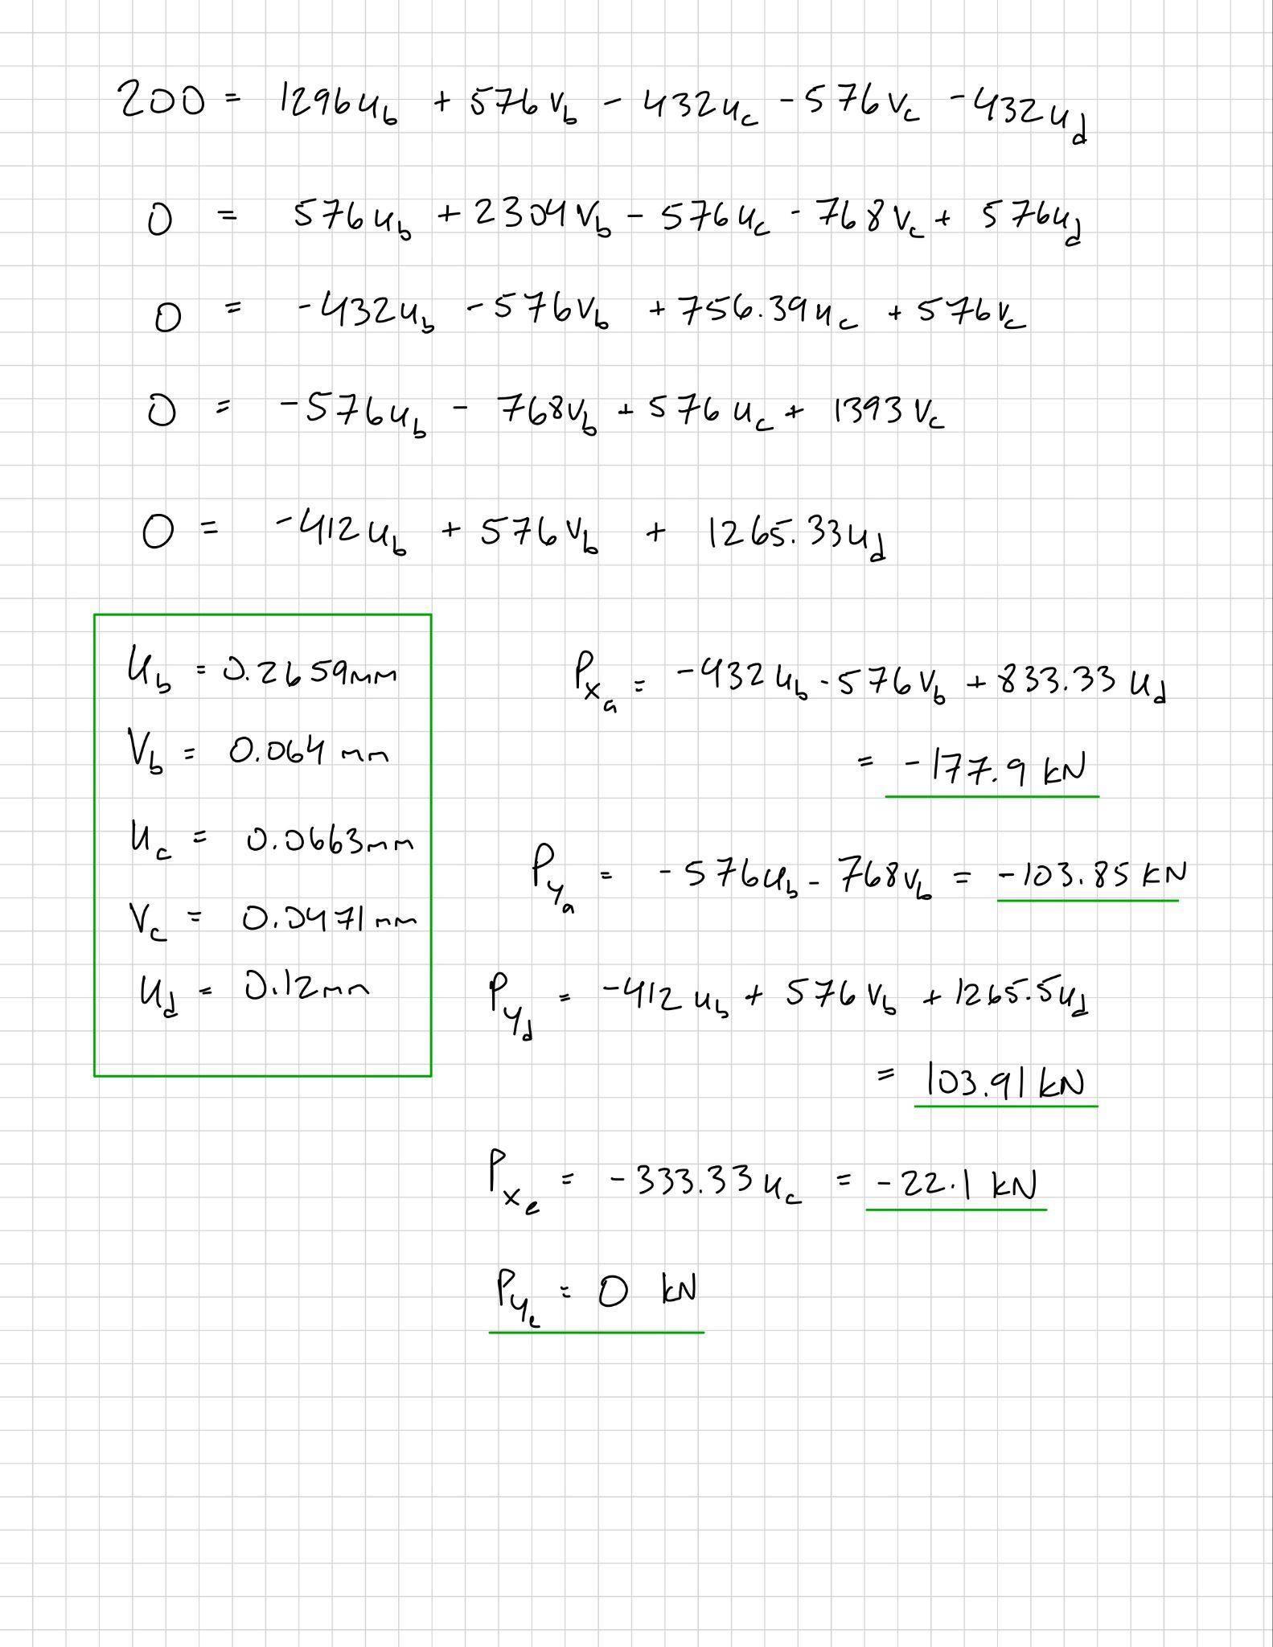

Comparing hand and Patran results reveals strong consistency: the dominant member BD carries roughly 1.67 x 10⁵ N in tension in both methods, while the supporting diagonals BA and AD follow at 1.30 x 10⁵ N and 8.3 x 10⁴ N. Differences between approaches are negligible (< 3 %) and are attributed to finite-precision rounding in the matrix solution. Both sets of results confirm that load transfer follows the diagonals between primary supports and that all displacements are within physically reasonable bounds for the given material stiffness.

Discussion/Conclusion
The finite element analysis for the four truss cases demonstrated how geometry and boundary conditions dictate internal load distribution in linear elastic structures. In every model, the highest axial forces appeared along the direct load paths between the applied load and the fixed supports, confirming the expected truss behavior. The maximum axial forces observed were approximately 2.24 x 10⁵ N in member AD for Case (a), 4.06 x 10⁵ N in BC for Case (b), 2.23 x 10⁵ N in AB/AD for Case (c), and 1.67 x 10⁵ N in BD for Case (f). All members primarily experienced axial tension or compression, with no bending or shear stresses, as predicted for 1-D bar elements. The largest displacements were small (around 2–5 x 10⁻⁴ m) and occurred at the free or loaded joints, aligning with realistic expectations for steel members with E = 2E+11 Pa and cross-sectional areas on the order of 10³ mm². These deflections indicate that the structures remained within the linear-elastic range, confirming model validity.

Comparing Patran/NASTRAN results to hand calculations showed excellent agreement, with differences typically below 3%. This minor variation can be attributed to rounding during stiffness-matrix formulation and numerical precision limits. Such agreement verifies that the finite element method correctly assembled boundary conditions, element stiffness, and load vectors. The results also emphasize how FEM simplifies multi-member analysis while maintaining analytical accuracy. The predicted stresses, obtained by $σ=F/A$, yield values under 225 MPa, which are well below the yield strength of structural steel (≅ 250 - 350 MPa). This suggests safety factors above 1.5, consistent with aerospace and mechanical design standards.

Overall, the lab achieved its objectives to analyze truss deformation and internal forces using FEM, compare them with analytical solutions, and evaluate the reasonableness of the response. The analyses confirmed that the software accurately modeled linear elastic axial behavior, provided physically reasonable displacements and stresses, and visually demonstrated how truss geometry governs load paths. From an engineering perspective, this reinforces that finite element tools, when properly constrained and interpreted, are reliable for validating analytical work and guiding the design of efficient structural frameworks.

